Template engine:

Something that allows you to build a template of how you want your page looks. we have the data and the template so we can build the final HTML.

🡪 a templating engine takes a bunch of static HTML files, fills them with the necessary data on the server side then sends them as any ordinary HTML file to the client.

Ex: handlebars, pugs

**Handlebars:**

[**https://handlebarsjs.com/**](https://handlebarsjs.com/)

**Ex:**

🡺 install handlebars 🡪 npm i express-handlebars

<https://www.npmjs.com/package/express-handlebars>

🡪 import engine 🡺 which allows us to render the webpages using the template files.



To register the engine with express app:

**1-**



app.engine 🡺 the first param is the type which is handlebars in our case, it could be ejs or pug 🡺the 2nd param is the callback fn returns the object

**2-**

app.set(‘view engine’, ‘handlebars’) 🡺 to set our app to use the handlebar engine

Our directory:

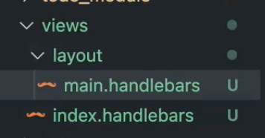

🡪 in the controller file, we render the page with data

🡪 we get the data using service.getItems()

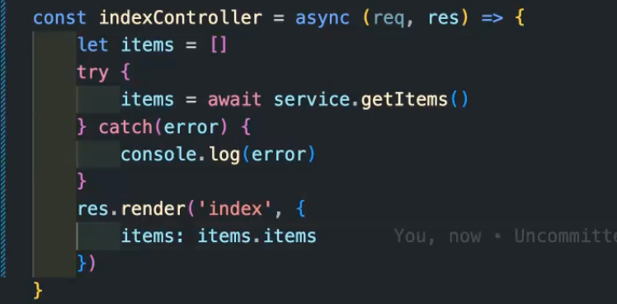

In service file

🡺 when you pass data from mongoose to handlebars, you need to call **lean()** fun 🡪 to get **JSON** object